RetailSaver

By: Vi, Desiree, and Lucas

# Problem and Solution Overview

Our team has created a financial app that aims to assist young adults between the ages of 18 and 22 in tackling impulsive spending. Our app merges conventional techniques to control impulsive purchases with digital convenience. Impulsive buying often results in financial instability and debt, as immediate gratification wins over long-term satisfaction. To combat these issues, it is vital to enhance financial management skills. Our app includes multiple features like monitoring budgets, tracking future purchases and recurring expenses, setting savings targets, and rendering investment education. Additionally, it provides financial education and resources that encourage long-term planning and delayed gratification. Our app utilizes technology and behavioral economics to guide young individuals toward building healthy financial habits and attaining monetary stability.

# Initial Paper Prototype:

Our initial design concept included screens allowing individuals to track their expenses, establish savings targets, and keep tabs on their investments. The primary responsibilities were organizing purchases and offering financial knowledge to users. Our main goal was to assist users in breaking the habit of impulsive spending by enabling them to plan their purchases ahead of time. Additionally, the educational aspect of the app was intended to provide users with valuable information on personal finance. We received feedback on the interface's clarity, the financial tracking features' comprehensiveness, and the ease of use.

The first version of the design had several screens, starting with a login page that allowed users to either login or create an account. After logging in successfully, the user would be taken to the homepage, where they could access various application features through a navigation bar at the bottom of the screen. By choosing each navigation option, the user could explore educational resources, make purchases, review investments, customize account settings, and view transaction history.

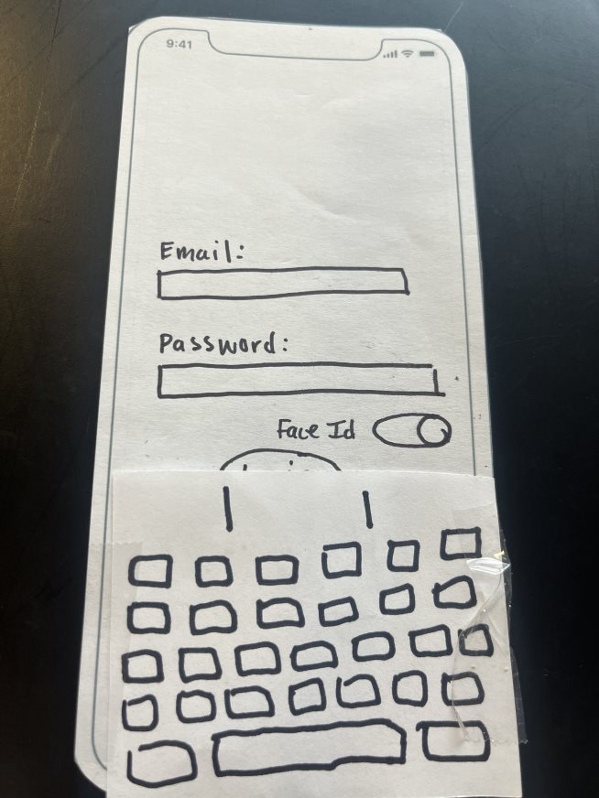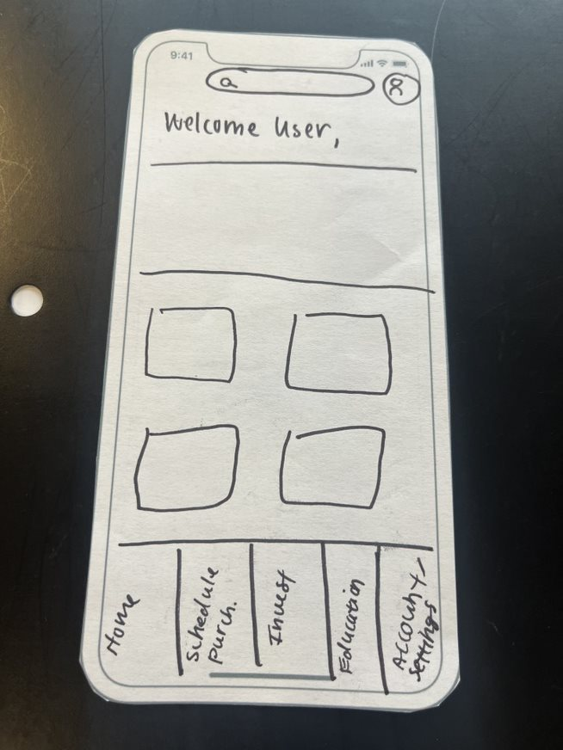

The user can click on each navigation feature to access educational content, schedule a purchase, invest, visit the homepage, and access settings and account information. Or they can navigate through the application with the search bar at the top of their screen.

The educational section divided the content into categories such as articles, videos, or podcasts. Users could filter the content based on their preferences or interests. For example, upon selecting a video, a screen would display a summary and a comment section along with the video. The related videos section showed other videos associated with the content. If the user selects an article, a screen will display, showing the article and pictures, along with details about the author and publication date. The related articles section displayed other articles related to the content.

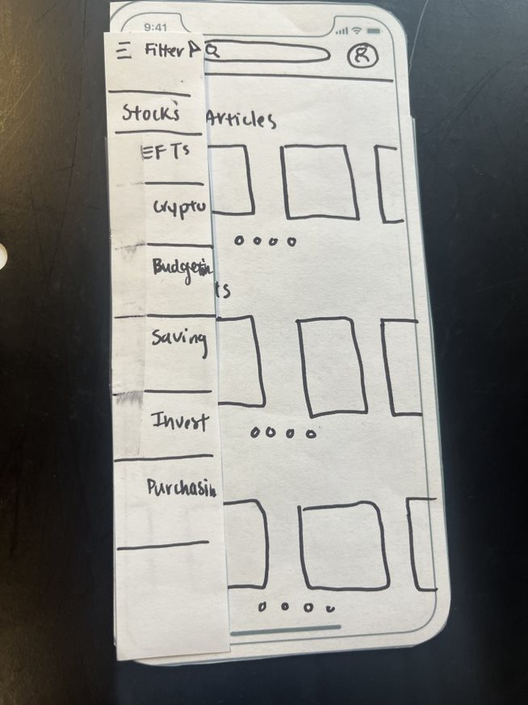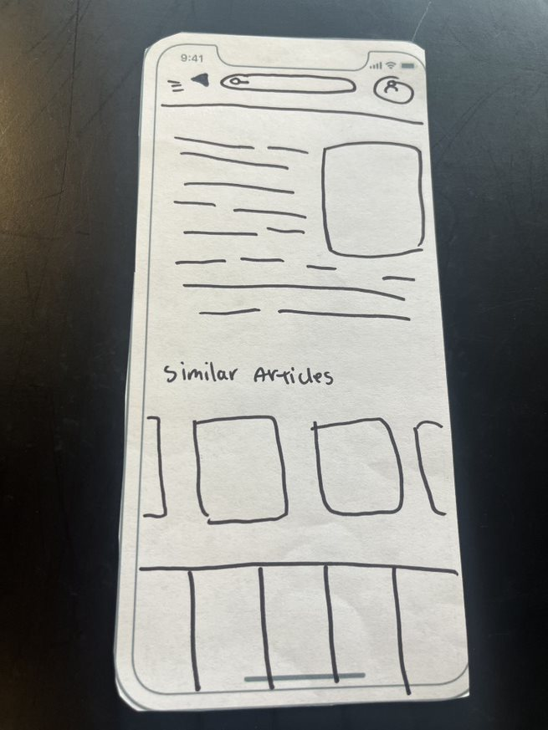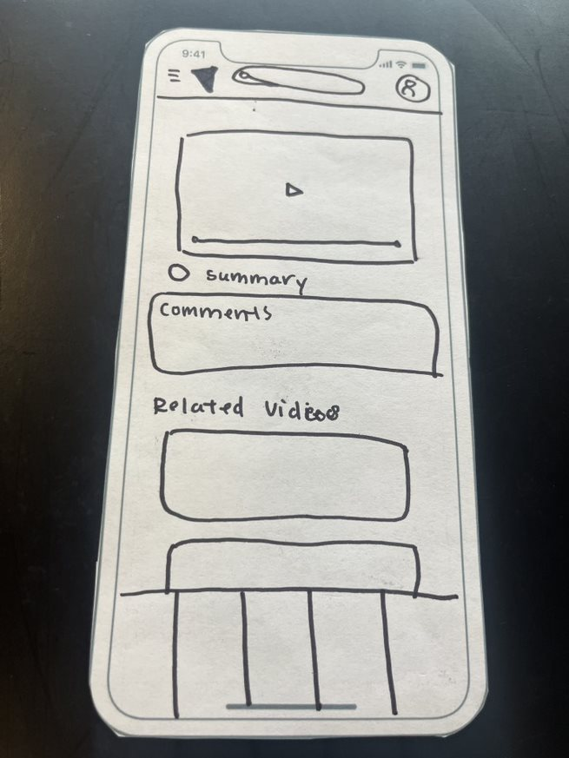

With the schedule feature, users can easily keep track of their expenses and avoid impulsive purchases for the month. By selecting a specific day on the calendar, users can view all transactions made on that day, categorized by vendor, item, and category. Users can select the "schedule a purchase" button on the navigation bar to access the calendar. The calendar displays all purchases, bills, and impulsive purchases for the month, with the option to navigate through different months. The page also summarizes total expenses, the average spent, and the total spent for the month. By selecting a specific day on the calendar, users can view all transactions for that day in a table format categorized by vendor and item.

Additionally, the Vault securely stores past purchases and expenses, allowing users to easily organize their transactions by sorting them by oldest, newest, amount, and frequency. The Vault has a security function that will redact or blur the transaction amount but will show the transaction name, the date entered, and the day of the transaction. Tapping to select a date on the calendar, will take the user to the Add Transaction screen, which will prompt them to insert the vendor, item, category, and price. If the purchase is categorized as impulsive, this will prompt a countdown to appear, which will detail the time that the purchase will unlock or the user will be able to make the purchase. To add the transaction to the calendar, the user would click on the add transaction button at the top of the screen. This would then navigate the user back to the purchase history home screen.

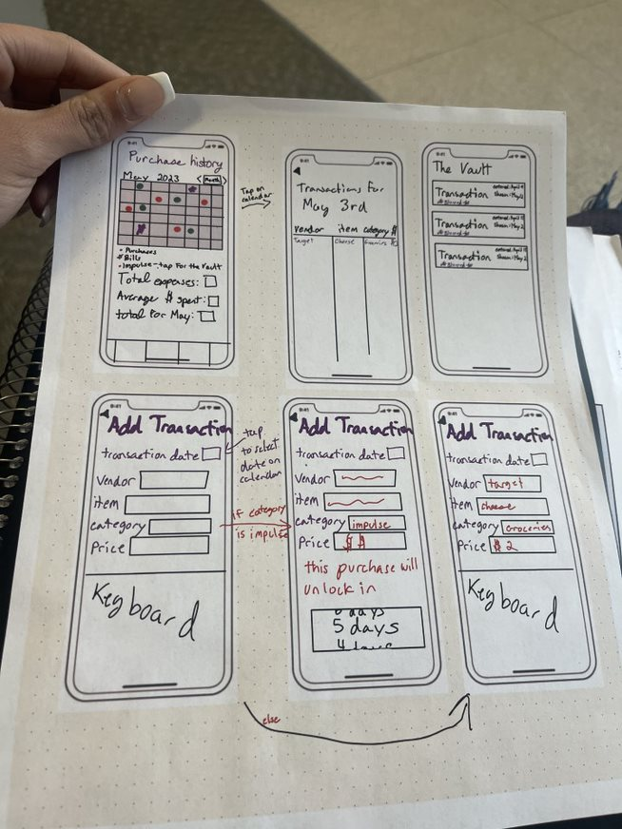

# Testing Process

We conducted heuristic evaluations and user tests to assess the usability and effectiveness of our paper prototype. Our test subjects were young adults aged 18–22 who belong to our target user group. We collected data through observations, surveys, and interviews. We also improved our testing process by considering the feedback received during our initial testing rounds. We refined our testing process by incorporating feedback from our initial testing rounds, adjusting our tasks, and improving the clarity of our instructions.

We started by thoroughly evaluating our prototype using a heuristic approach. We enlisted the help of several testers to try out our paper prototype and assess its usability. We allowed the testers to navigate the screens independently while performing specific tasks to gauge usability. We observed their interactions and took detailed notes. We then analyzed the results and created a report on our findings, which we used to enhance our instructions and make them more efficient. However, we encountered a few things that could have been improved during the evaluation process. For instance, some testers found it challenging to complete specific tasks because they needed a keyboard or back buttons, which we had overlooked in the initial prototype. Additionally, we realized that some navigation features could have been more intuitive than we had assumed. We took note of these issues and made the necessary adjustments to ensure our instructions were practical and user-friendly.

Based on the findings from the heuristic evaluation, we have made certain modifications to the prototype. These modifications include adding keyboard and back buttons to enhance the system's visibility and accessibility. Additionally, we have changed some of the navigation features to make them more intuitive and user-friendly.

As part of the cognitive walkthrough, we placed ourselves in the shoes of a user attempting to navigate the app. We thoroughly examined every stage of the user's journey and how we could enhance our prototype's usability and overall user experience. This approach enabled us to pinpoint potential problems and view the application from the user's perspective. Additionally, we requested participants' input better to understand their opinions and emotions regarding the application.

Our main objective during the cognitive walkthrough was to ensure that the application was navigable for users. Our priority was ensuring that the assigned tasks were completed effortlessly and without significant obstacles. Throughout the walkthrough, we carefully observed the participants' interactions with the prototype, noting any issues they faced.

As we conducted our study, we requested that participants articulate their thinking patterns as they interacted with the app. This enabled us to understand their interpretation of the interface and decision-making process. As a result, we could pinpoint areas where the interface was ambiguous or perplexing and make design enhancements.

We also requested user feedback on their overall experience with the application. They were asked to rate the app's interface and usability and give suggestions for enhancing the user experience.

We received valuable feedback from our participants after conducting heuristic evaluations and cognitive walkthroughs. Our system's visibility and user-friendliness significantly improved with the addition of back buttons and a keyboard. However, some users needed help locating the educational content within the application during the cognitive walkthroughs. This feedback helped us adjust the layout and labeling of the educational content so that it is more accessible and prominent within the application.

In addition, we could observe how users interacted with the application in various environments by conducting tests in both a residential setting and a classroom. We discovered that users were more efficient at completing tasks in a quiet environment with fewer distractions.

After making changes to the prototype based on the feedback received during the heuristic evaluation and cognitive walkthrough, we conducted user testing with three participants. Given more time and resources, we would have asked for more participants. Instead, these participants were recruited from the same population as our cognitive walkthroughs: college students. Participants were randomly assigned to one of two groups: the control group, which was given the original prototype without any modifications, or the experimental group, which received the updated prototype.

Each participant was given a set of tasks to complete using the prototype, including scheduling a purchase and locating educational content. They were also asked to provide feedback on their experience with the prototype, including any issues they encountered or suggestions for improvement.

We found that participants in the experimental group had an easier time completing the tasks and reported a more positive overall experience with the prototype. However, they also provided valuable feedback on areas that could still be improved, such as the layout and organization of the application.

Through the testing process, we identified areas for improvement for our prototype and made necessary changes to enhance the user experience. In addition, the roles assumed by each team member during testing enabled us to gather feedback efficiently and implement updates in real-time.

# Testing Results

Our testing revealed several usability issues with our initial paper prototype, including confusion about navigation, difficulty finding certain features, and a need for clarity in the language used. As a result, we made several changes, including reorganizing the navigation menu, simplifying the language used, and adding additional prompts to guide users through the interface. As a result, our second round of testing showed improvements in user understanding and ease of use.

After conducting a thorough testing process, we identified several issues with our initial design. Our heuristic evaluation revealed that our design violated multiple heuristics, including the absence of critical components like back buttons and keyboards on our paper prototype. This lack of functionality compromised visibility and user control, essential to efficient navigation. To address this, we revised our design to include these essential features, making it easier for users to access and navigate the application seamlessly. As a result, users can now transition smoothly between pages, which was not possible before. Detecting navigation errors in a design is crucial since it forms the foundation of effective navigation. With our improved design, users can now transition smoothly to previous pages, which was not possible previously due to the absence of these critical components. Therefore, ensuring navigability is vital to a good design to enhance the user experience.

| Identified Issue | Heuristic violated | Severity | Revision |
| --- | --- | --- | --- |
| No Keyboard | Visibility of system  User control and freedom | 4 | Adding in keyboards on the necessary screens that’ll allow the user to input |
| No Back Buttons | Visibility of system  User control and freedom | 3 | Adding in back buttons on screens that’ll allow the user to easily go back to the previous page |
| Complexity of Scheduling a Purchase/ Unclear on how scheduling a purchase reduces impulsive purchases | Recognition rather than recall  Help and documentation | 2 | Adding a demo video that the user can access which will demo the process of scheduling a purchase and will inform the user how delaying their impulsive purchases by scheduling them will help manage their impulsive spending habits |
| One reoccurring theme/issue present with each testing was the complexity/unclarity of the scheduling a purchase design | Help and documentation | 3 | For revisions we decided to add a tutorial that would introduce the user to various functions of the app. |

We made some changes to our application and then performed a cognitive walkthrough to test its functionality. While doing so, we realized the vault screen could become too cluttered with transactions. With a filter option, it would be easier for users to browse through the screen. To solve this problem, we introduced a filter option to help users easily locate specific transactions.

We then conducted a usability test to assess the purchase feature in our application. Based on feedback from our heuristic and cognitive walkthroughs, we discovered that users needed help interacting with and comprehending the design. Results from the usability test confirmed that the screen's overall design could have been clearer for users, which presented a significant challenge. It was essential to identify this issue as it hindered users' ability to use the feature effectively.

To address these concerns, we implemented design changes and developed a brief tutorial video to clarify the purpose of scheduling purchases and simplify the feature for users. In addition, through conducting these tests, we incorporated user feedback and improved the functionality and user-friendliness of our design for the final product.

During our cognitive walkthrough, we observed that the vault screen might become complicated with numerous accumulated transactions, making it challenging for the user to navigate without a filtering option. Consequently, we incorporated a filtering option to facilitate ease of use for the user when locating specific transactions in the vault.

During the usability test, we discovered some issues with the purchase scheduling feature in our application. The heuristic and cognitive walkthroughs revealed that users found interacting with and understanding the design challenging. The usability test results confirmed that the screen's overall design could have been more apparent to users.

One problem with this interface is more clarity on scheduling purchases and how it helps prevent impulsive buying. Users must understand the purpose of this feature and its benefits for reducing impulsive purchases. To address this, we've added a short tutorial or educational video that explains the purpose of scheduling purchases.

After conducting a series of tests, we could modify our designs based on the valuable feedback we received. The insights provided by the users' perspective helped us identify issues that we, as designers, may have yet to notice. These tests greatly influenced the final stage of our design, making it more functional and user-friendly.

# Final Paper Prototype

Our final paper prototype featured a simplified interface, clear navigation, and easy-to-understand language. Users could easily add new expenses, monitor their savings goals, and track their investments. First the user would start at a sign up page where the user would enter their email and designated password. If the user already has an account, they can log in with their credentials and will be sent to the home page after the log in page. This page includes recommended articles or videos from the education page. On the bottom part of the screen there is a navigation bar which is ordered by home, scheduling, investing, education, and settings. The first addition that we made to our initial prototype is adding back buttons for our education, scheduling, and vault page.

**Final Vault Page:**

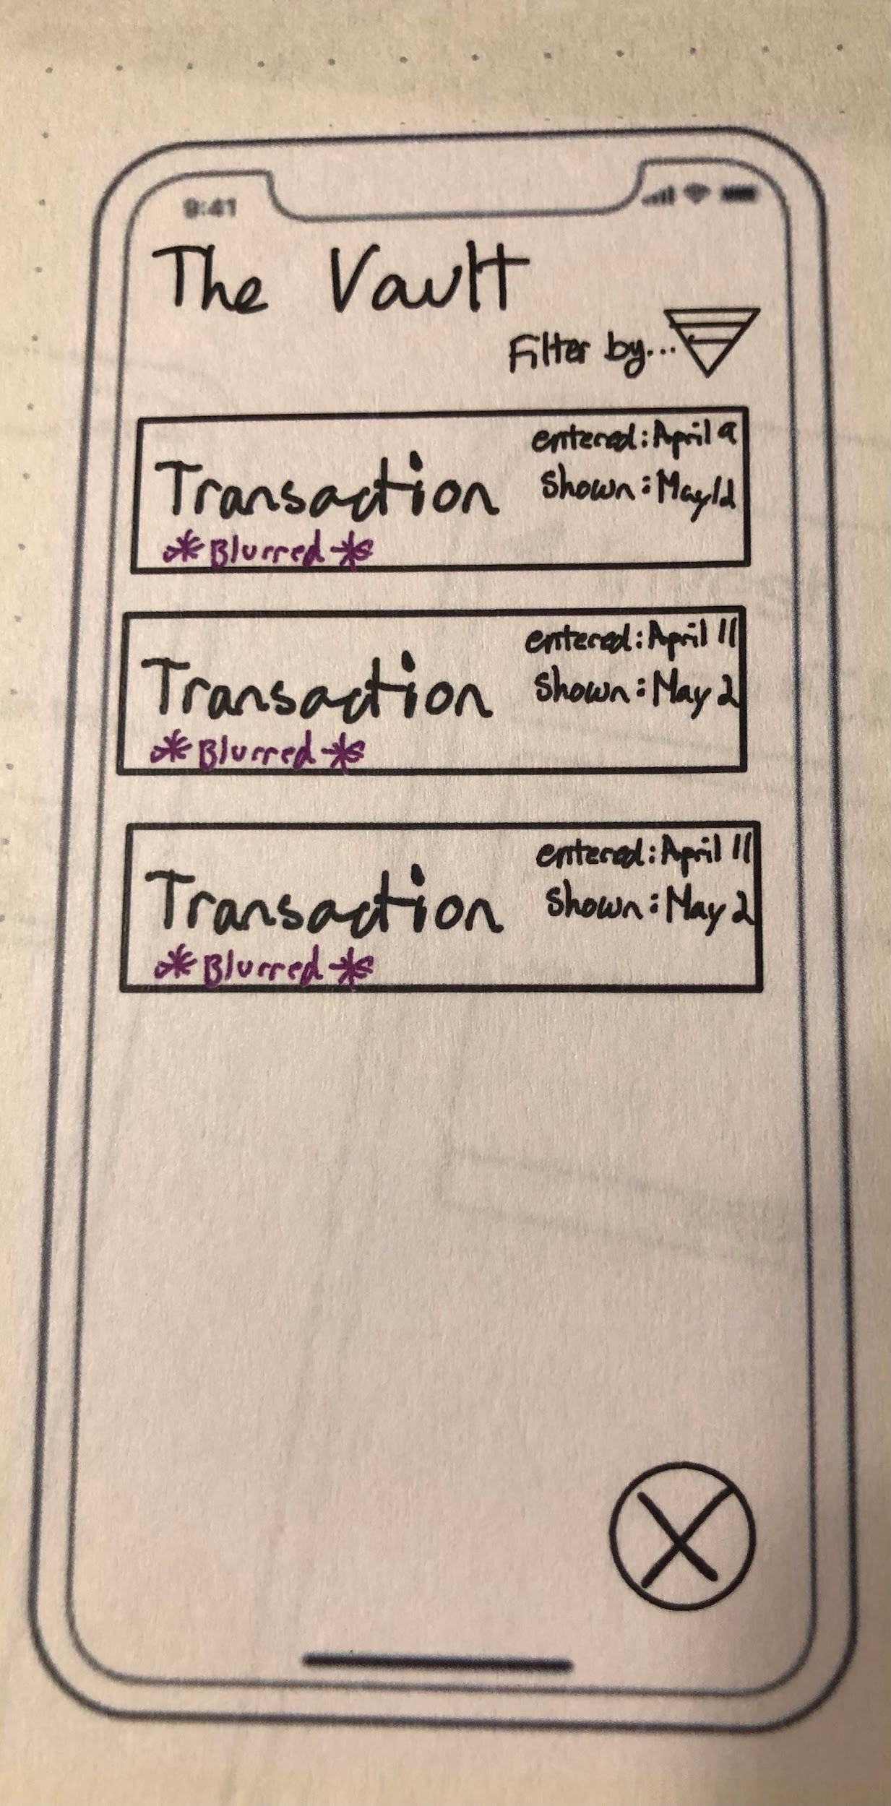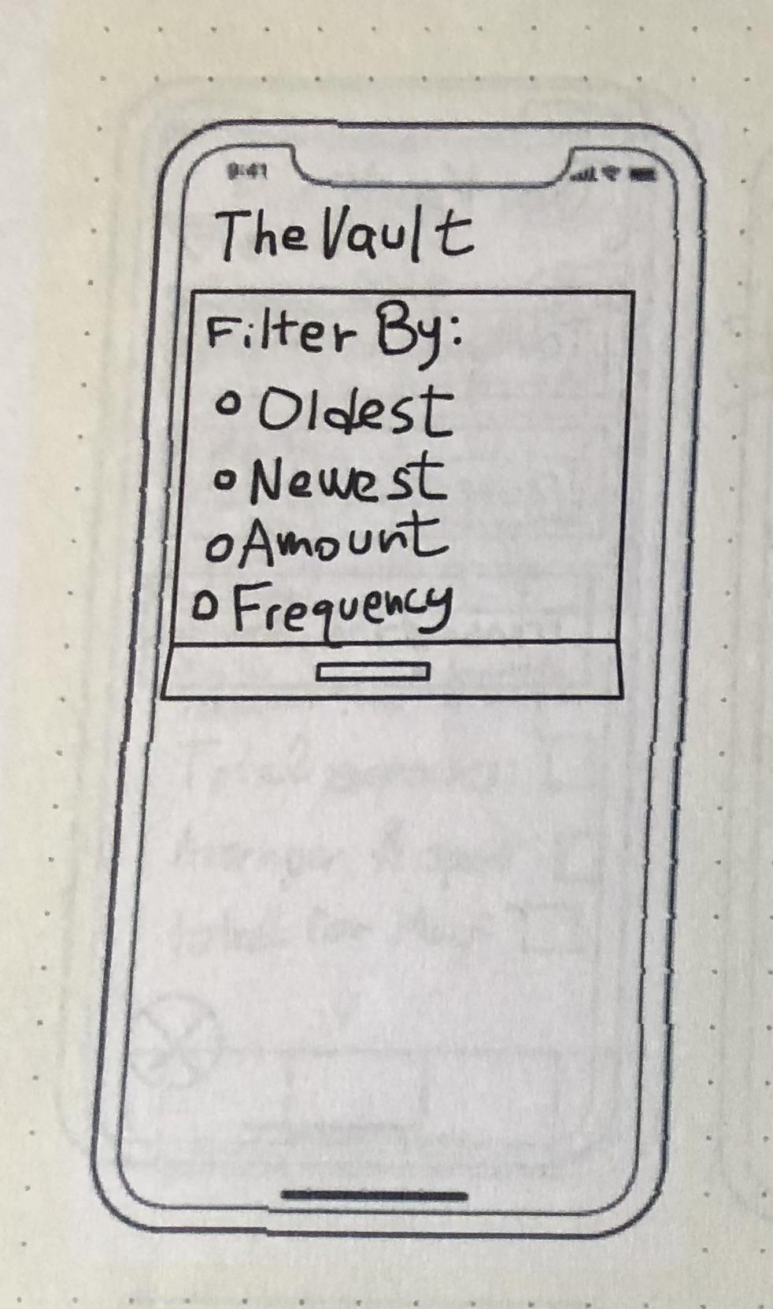

The second addition was editing The Vault page so that there was an ability to sort the page since transactions would accumulate over time and users should be able to look at past expenses and use their budgeting skills with this past expense information. This is critical for the budgeting task of this app. Users would be able to make judgement calls on their finances based on past information in The Vault. We want our scheduling app to be as informative as possible since users should learn from the education interface about tracking expenses which is a valuable skill of budgeting.

**Final Investment Page:**

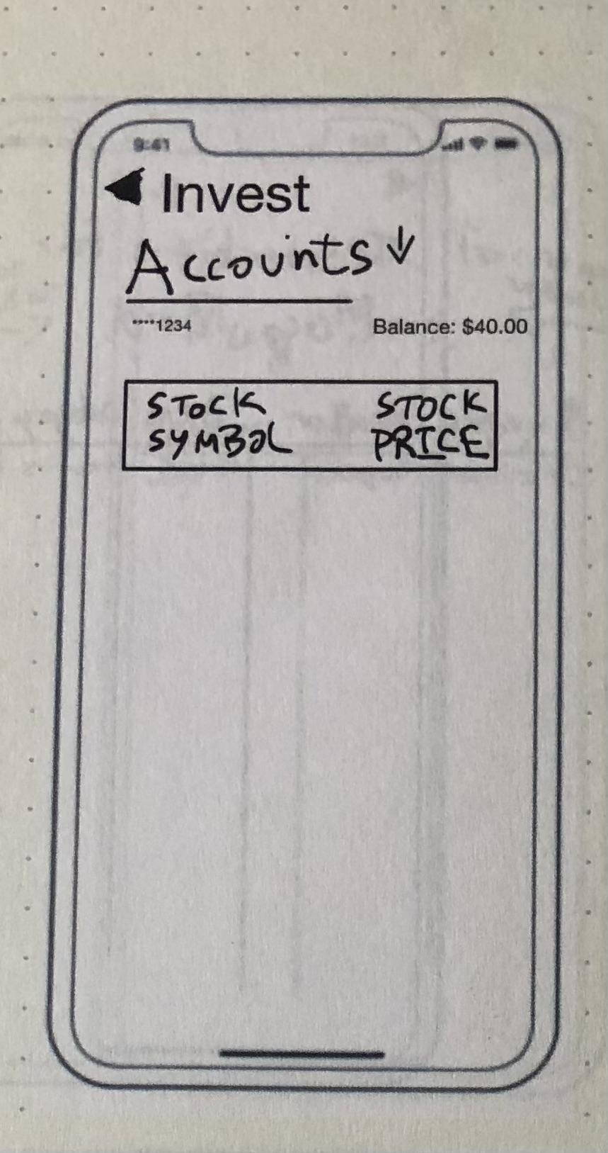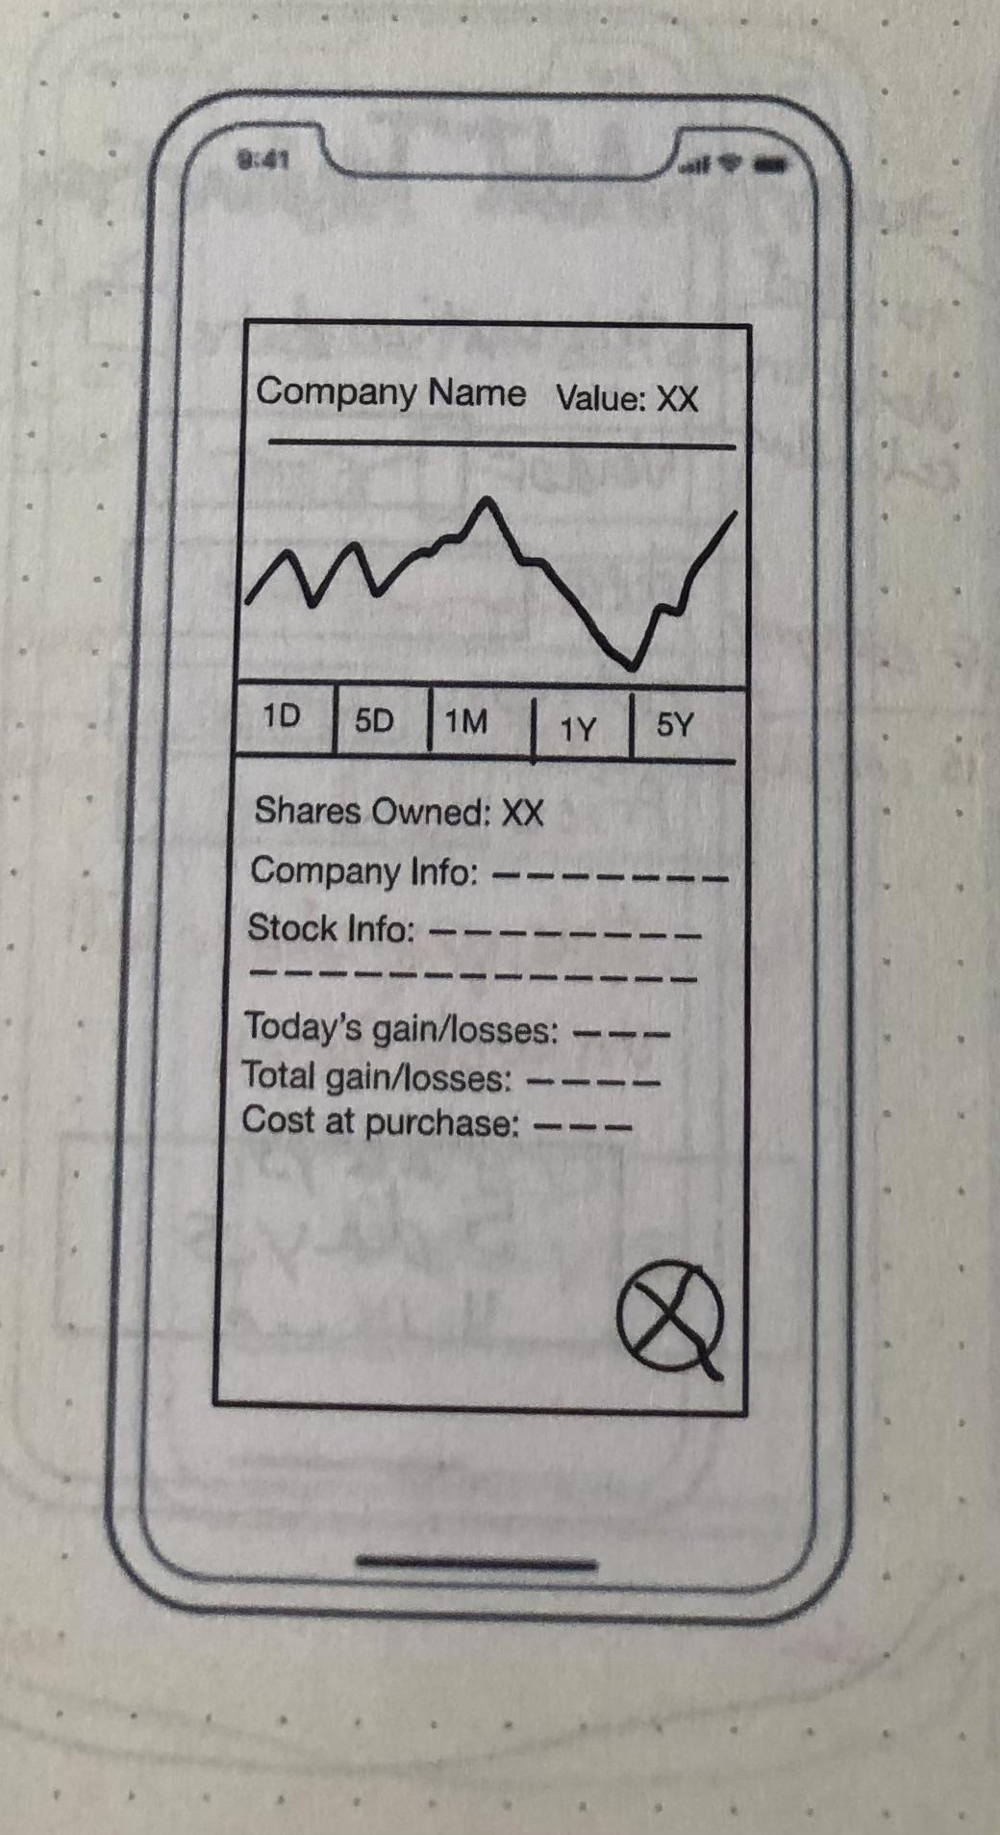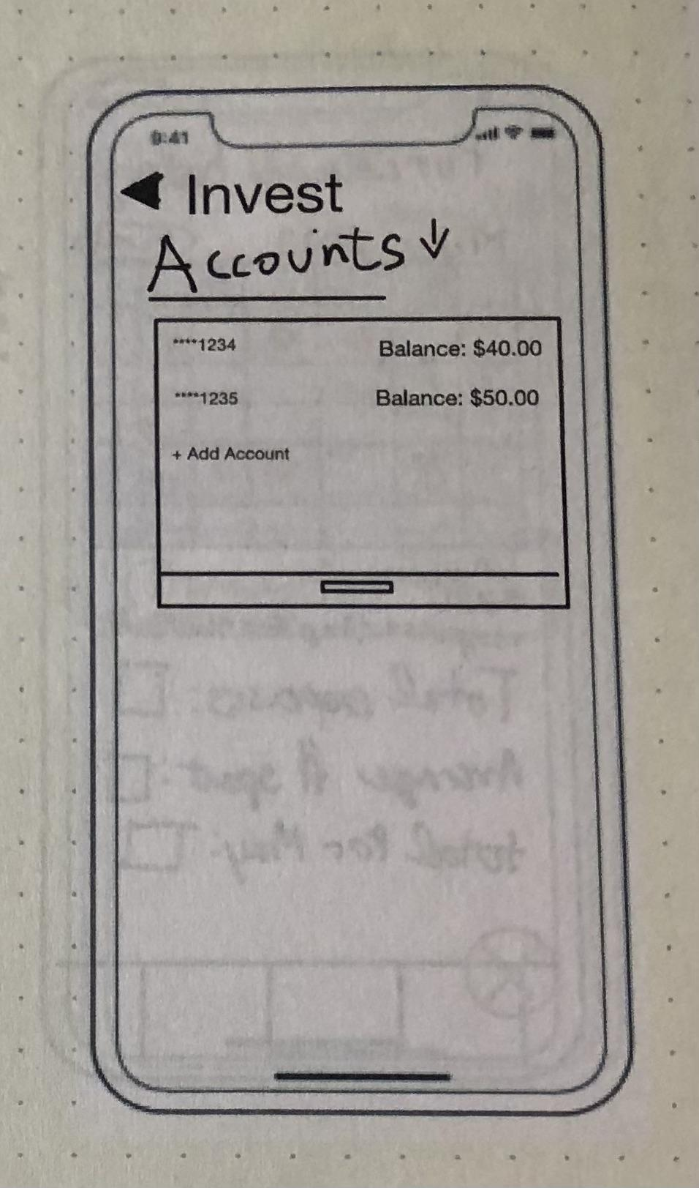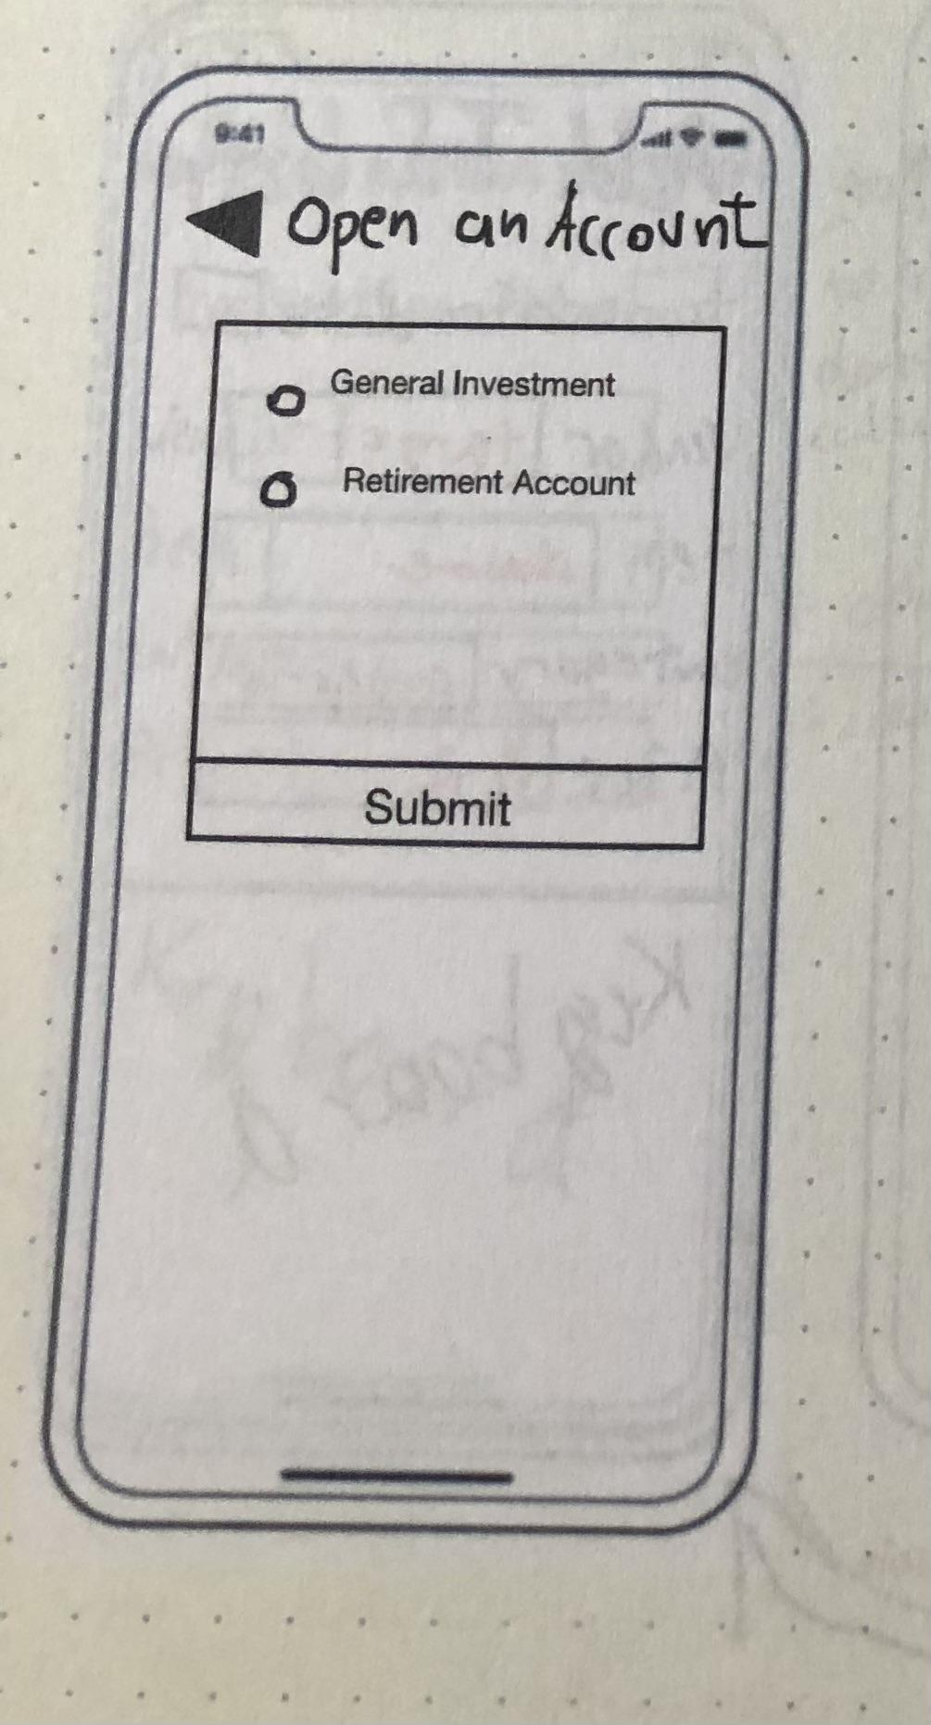

The last addition was adding the investment page. We wanted users to be able to implement the education part of our app so I added a basic investing interface that currently only works for general stocks in a regular stock portfolio or a retirement account. The targeted task for the final additions of the prototype is education. Our education page would include popular articles and insightful videos on budgeting, investing, stocks, among other relevant topics and our user had no way of implementing the education on the app. The investment page would be recommended for people who have experience investing or those who have learned about investing in the education portion of our app. Users can see the stock information and trends from the day of and up to 5 year trends. Users would also be able to add an investment account or retirement account which would be the account from which they are trading. Users would be implementing education in both scheduling and investing which is something that many investment apps on the market do not offer.

# 

# Digital Mockup

We transitioned from our paper prototype to a digital mockup, which allowed us to enhance the visual design and usability of our application. We made several changes based on feedback gathered from user testing and other design considerations. These changes greatly enhanced the user experience of the finance app and made it more intuitive and easy to use.

One of the most significant changes was the inclusion of back buttons on various screens. This was in response to user feedback, as users found it challenging to navigate the app without a clear way to return to the previous page. The addition of back buttons made the user experience more intuitive

The tutorial was also a new addition to the app and was created to help users familiarize themselves with the app's features and functionality. A brief introduction to the app was found to be very helpful, as users could more easily understand how the app differed from other finance apps. The tutorial guides users through the app's core functions, such as searching for content, adding items to a watchlist, and setting up notifications.

The search function was enhanced with the addition of a search results page. After a user enters a search query, the app displays a list of relevant results on this page. This provides users with a clear view of their search results, rather than having them displayed alongside other content. The sort/filter page was also added, allowing users to refine their search results by sorting and filtering by different criteria, such as date or relevance.

To provide users with more educational content on finance, separate sections for articles and podcasts were added to the app. This feature helps users discover new content and broaden their knowledge of finance.

Finally, a settings/profile page was added to give users control over their account settings and preferences. This feature allows users to update their profile information, change their notification settings, and adjust other app preferences from this page.

Overall, these changes were made to improve the user experience of the finance app. The new features and functionality provide users with more control over their experience and more ways to discover and engage with content on finance.

**Sign Up Screen:** Upon opening the application for the first time, users can input their personal information by tapping on each individual field to show a keyboard. Their their name, email, password, and password verification are entered in. If they prefer, they can click "show" next to the password field to reveal or double check their password. Additionally, they can choose to opt-in or opt-out of promotional materials by checking the corresponding box. If a user already has an account, they can navigate to the login page instead.

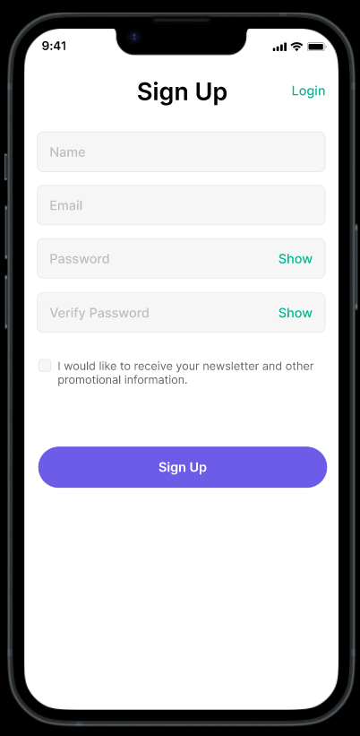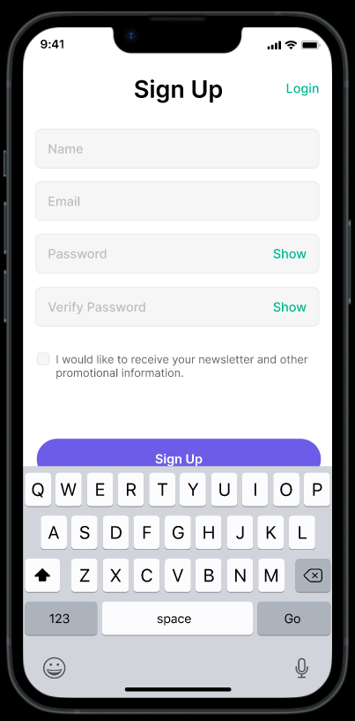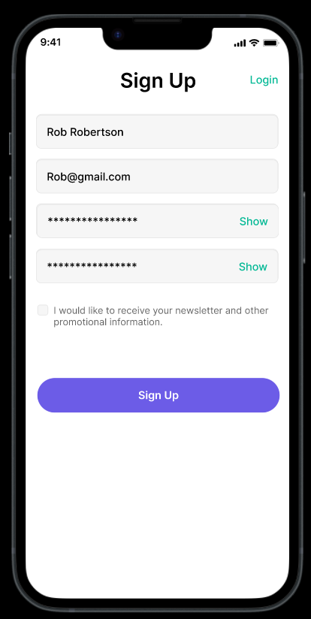

**Sign in Screen:** When opening the app, users will see a login screen with options to sign in using their credentials or face ID, as well as the option to create a new account. Since the app is personalized for each user, having an account is necessary to access all of its features. To make account creation easy and seamless, we have included a Sign Up Screen, which users can navigate to at any time.

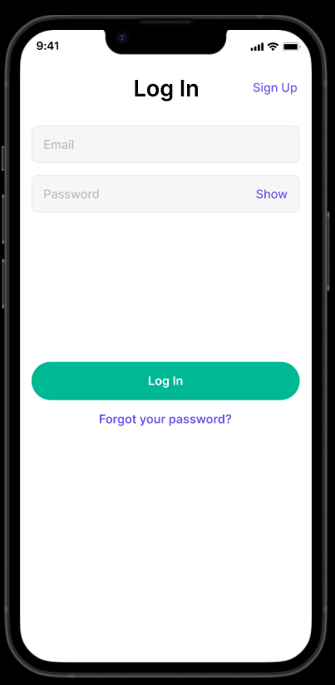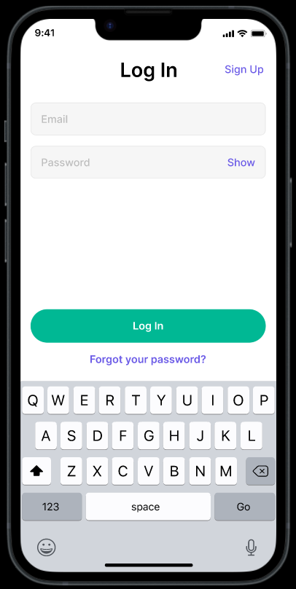

**Homepage:** Upon first use, users are greeted with a warm welcome page and a "welcome to our app" popup that will prompt them to go through a tutorial. Users have the option to skip the tutorial. For returning users, the home screen is the second page they see. The navigation bar located at the bottom of the screen allows for easy access to different features of the app, including home, view transactions, investing, education, and settings/profile page. By selecting a navigation feature, users are able to explore educational content, schedule purchases, make investments, access their personal account information and customize settings. Alternatively, users can utilize the search bar located at the top of the screen for quicker navigation.

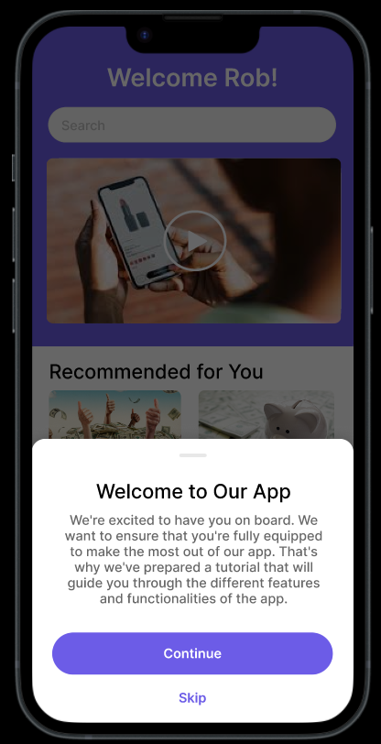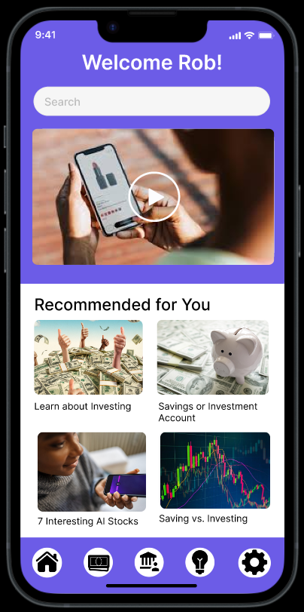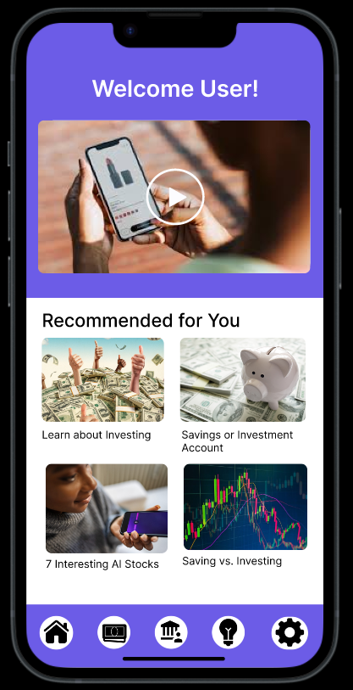

**Search Results Page:** When a search bar is present on a screen, users can search for specific content by typing in their query and pressing "enter." The app will then bring them to the search results page where they can easily navigate to the relevant information. This is a page added from the paper prototype.

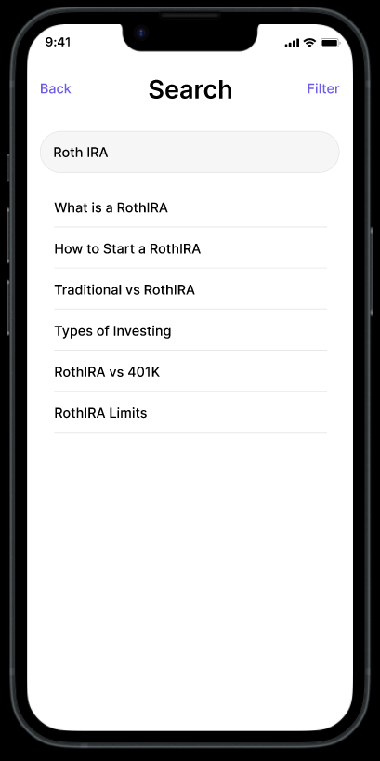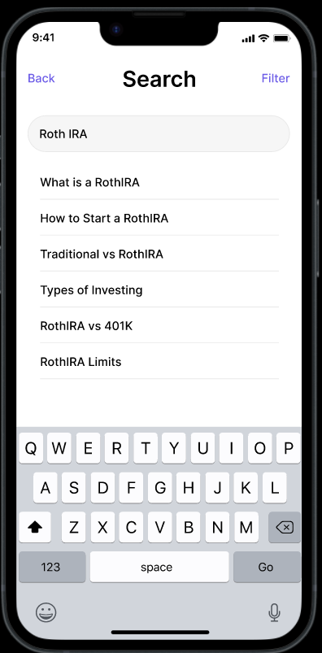

**Filter & Sort Page:** On certain screens, a filter option is available in the top right corner, which enables the user to navigate to the filter or sort page. This feature allows the user to refine their search by filtering by type, keyword, date, and more, depending on the page. Sorting by different factors is also available.

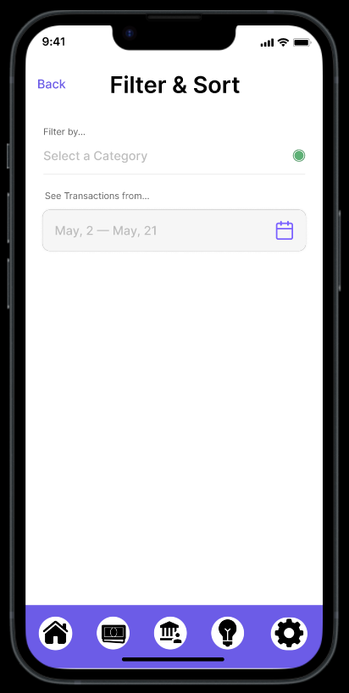

**Education Home Screen:** The Education Home Screen is a treasure trove of valuable educational resources that cater to diverse learning styles. Users can explore an extensive collection of articles, videos, and podcasts that are conveniently sorted by media type. To further customize their experience, users can utilize the drop-down menu in the upper left corner to filter content based on their preferences or specific topics of interest. The search bar located at the top of the screen also enables users to quickly find relevant content by entering relevant keywords. Once users have selected their desired content, they will be seamlessly redirected to a new screen that corresponds to the chosen media type.

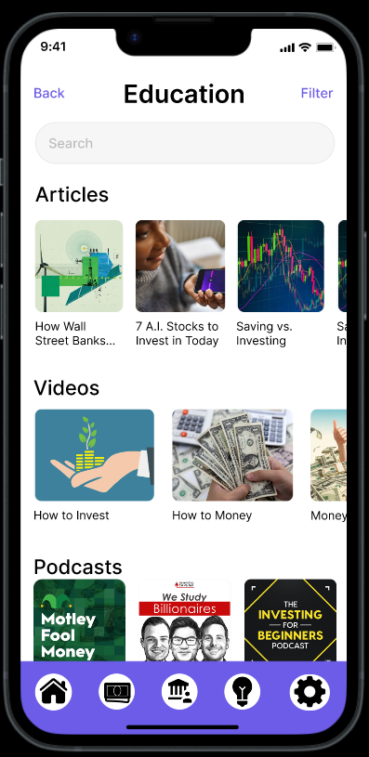

**Videos**: The video page displays the selected video in a large format, allowing users to easily watch and learn. Users can play, pause, adjust the playback speed, and add captions as needed. A brief summary of the video's content is provided, and users can share their thoughts in the comment section. Related videos are also displayed for further learning. To return to the previous page, there is a "back" button in the upper left corner. After completing the tutorial, users will be congratulated on a job well done with a pop-up message.

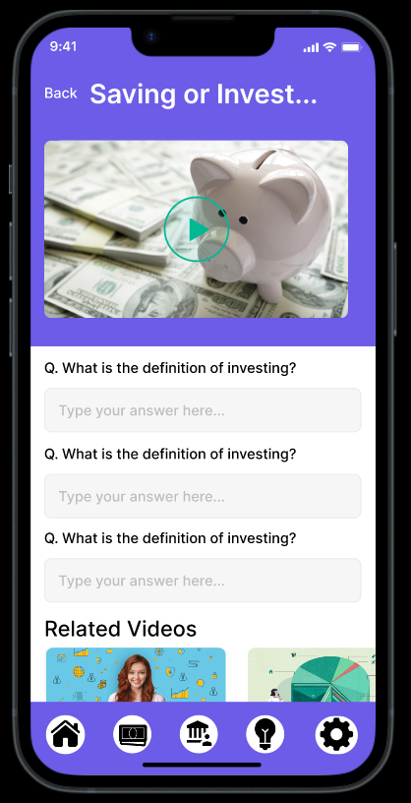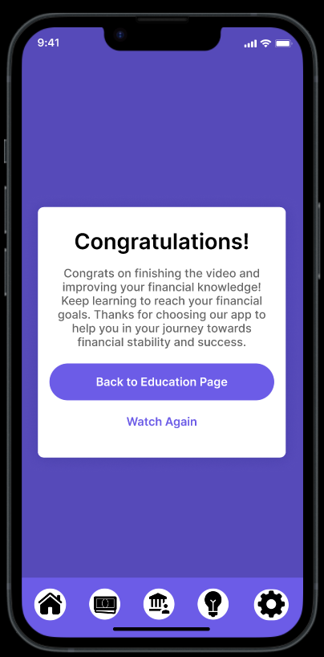

**Articles:** By selecting the article the user is prompted to a screen which displays the selected article and pictures alongside the article. At the top of the article is information about it, such as the author, and or publication date. The user is able read the full length of the article through scrolling, and is able to access the previous page they were on through selecting the arrow in the upper left corner. Below is a related articles section which would allow the user to see other articles related to the content that they are reading.

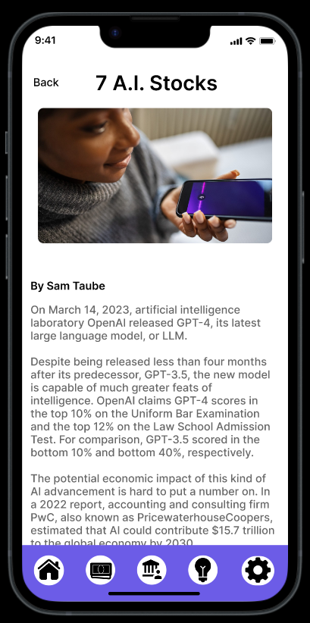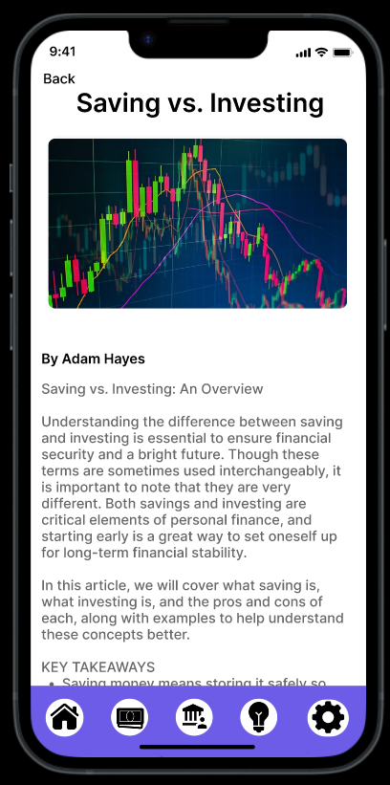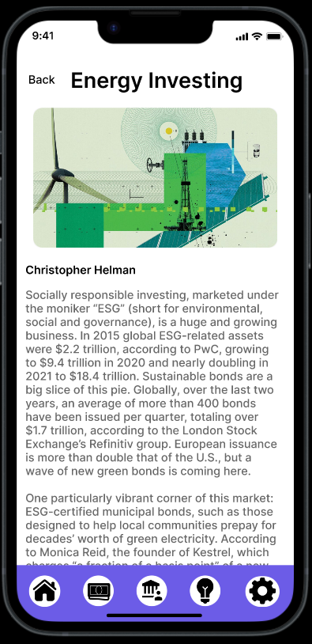

**Podcasts:** By selecting the podcasts, the user can see relevant podcasts. This is a page we added from the paper prototype.

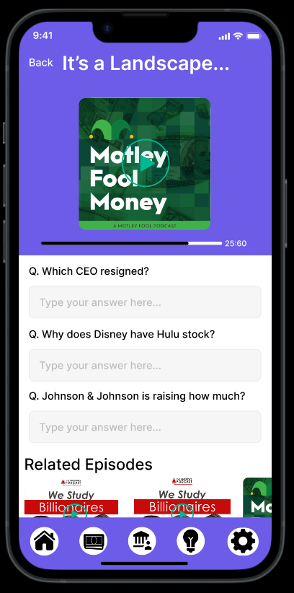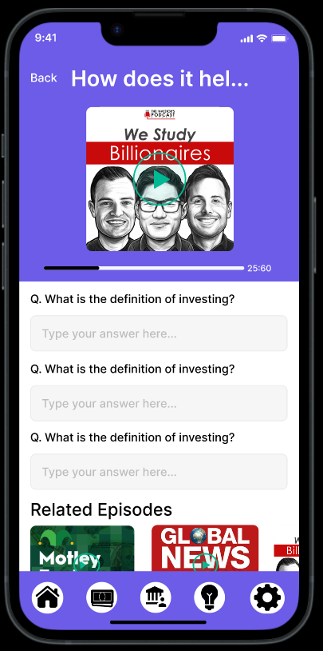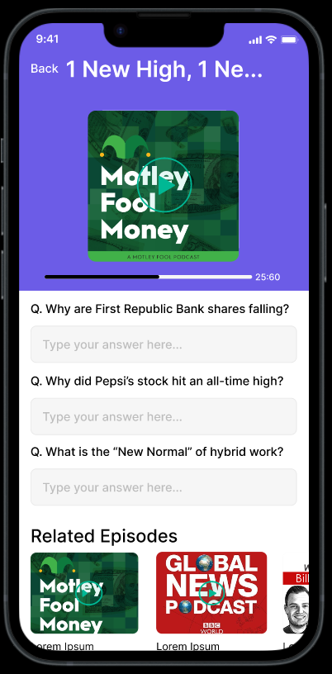

**Purchase History Home Screen:** By selecting the schedule purchase screen the user is able to see a calendar which depicts their purchases, bills, and impulsive purchases according to the month. The user is able to navigate through the months at the top of the calendar. This page also offers a summary regarding their total expenses, average money spent, and total spent for the month.

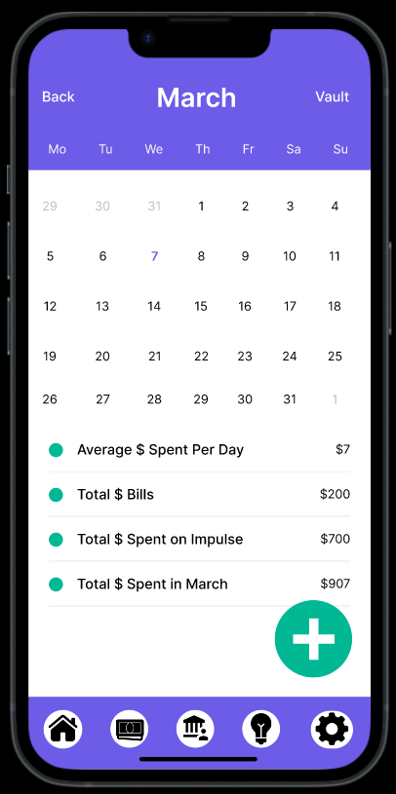

**Purchase History Day Screen:** By selecting a day on the calendar the user is able to see all the transactions for that given day. This is broken down into a table according to the vendor, item, and category. This screen also features a back button which would allow the user to easily visit the previous screen.

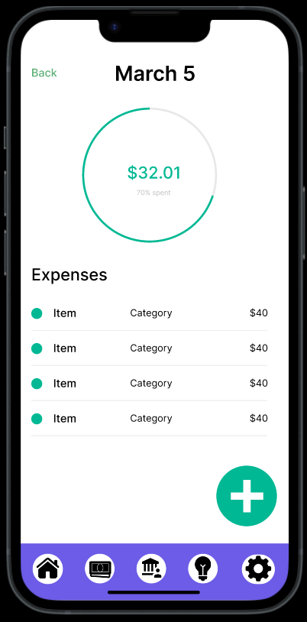

**The Vault:** The vault is where past purchases will be stored along with past expenses. The Vault has a security function that will redact or blur the transaction amount, but will show the transaction name along with the date entered and the day of the transaction.

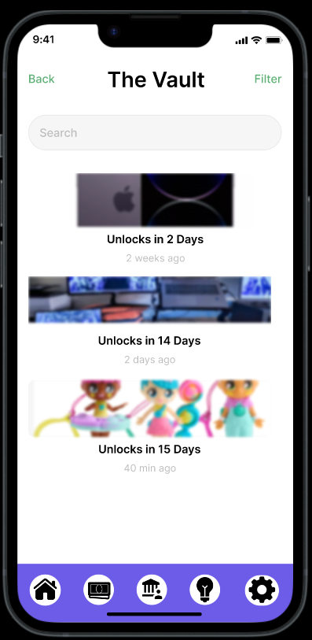

As more transactions are added to the the vault, it will get more crowded and harder to scroll through. The sorting function sorts the vault by the oldest, newest, amount, and frequency which allows the user to do with this information as they please.



**Add Transaction Screen:** This screen allows the user to schedule impulsive purchases. This is done by tapping to select a date on the calendar, inputting the vendor, item, category, and price. If the purchase is categorized as impulsive, this will prompt a countdown to appear which would detail the length of time that the purchase would unlock, or that the user would be able to make the purchase. In order to add the transaction to the calendar the user would click on the add transaction button at the top of the screen. This would then navigate the user back to the purchase history home screen.

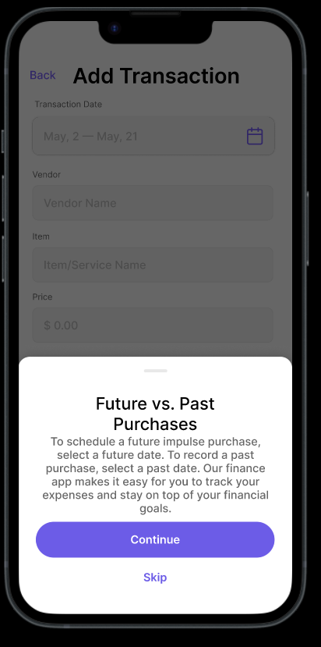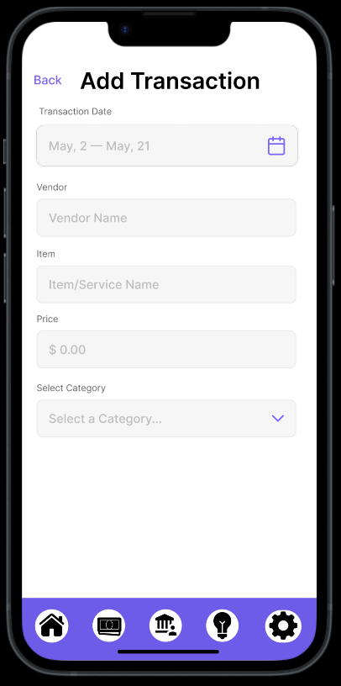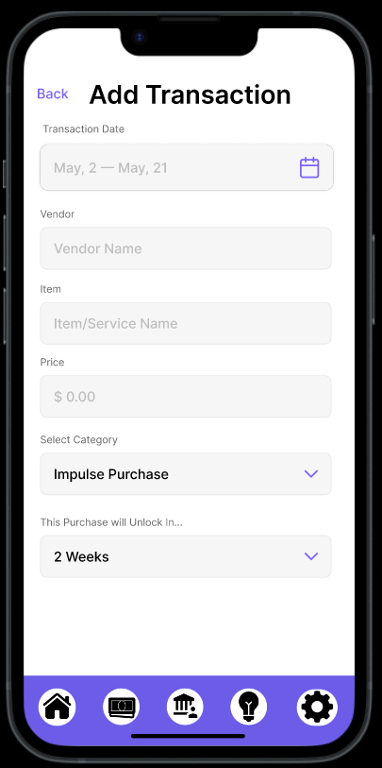

**Invest**: The investment screen shows the first investment account that user has. It will show the stocks that the user owns as well as the stock price and balance in the investment account. There is a drop down which is indicated by the down arrow next to Accounts which will drop down to show other investment accounts that the user may have. Adding fund into this investment account can be done at the bottom of the screen where the user may type in how much they would add into this account from their bank account. Bank account set up would happen during the sign up phase of the app.

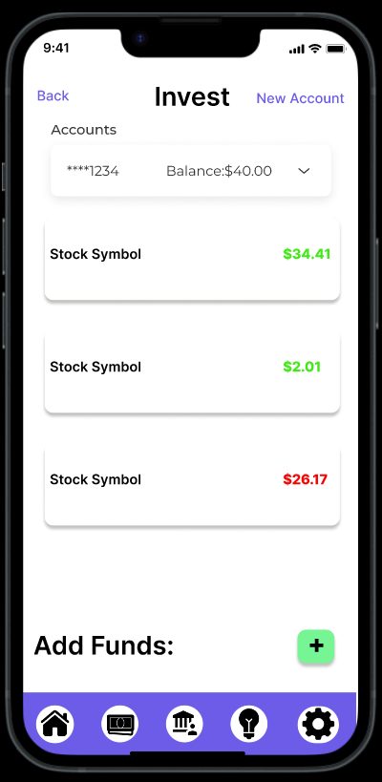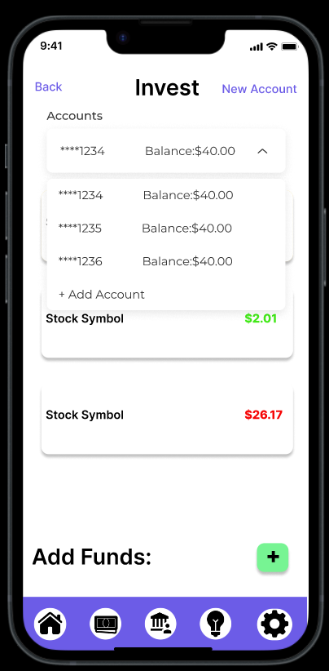

More information about the stock will pop up when the stock is tapped. Public information will be displayed about the stock trends, company info, stock news/info, gains/losses on the day, total gain/losses, as well as the cost of the stock at purchase.

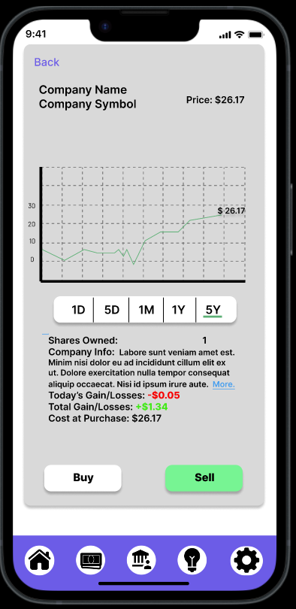

When the Accounts dropdown is tapped it shows any other accounts that the user may have along with the balances left to trade in each of those accounts. If the user does not have an investment account, the user can tap Add Acount to create a new investment account



When accessing the app's investment section, you will be presented with two options for opening an investment account. It is assumed that you have previously utilized the education section of the app to gain an understanding of the different types of investment accounts available. Alternatively, if you wish to create additional investment accounts, these options will also be available to you.

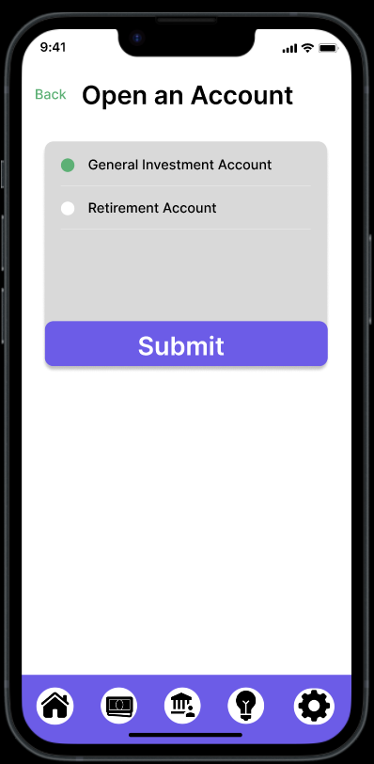

**Settings/Profile Page**: The Settings/Profile Page is an added feature from the paper prototype. This page allows users to view and update their personal profile information. Users can also toggle between light mode and dark mode, adjust notification settings, and logout from their account. It provides a personalized experience for users, giving them the ability to control their preferences and settings within the app.

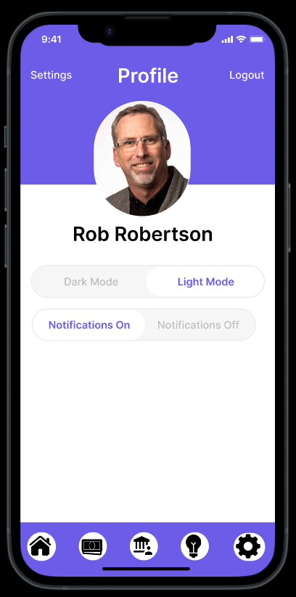

# 

# Discussion

Design iteration is a process that involves making gradual changes to a design based on feedback and testing. Our project taught us the importance of paying attention to the smallest details, such as adding back buttons, which can significantly impact the user experience. We must also balance our vision with the users' needs in mind. It's easy to get carried away with our ideas and forget that the app should meet the users' expectations. We must prioritize the user experience to ensure that our app is easy and intuitive to use. Testing and feedback from users are essential tools to refine the user experience. Ultimately, a successful app is one that meets the users' needs while fulfilling its purpose.

During the iterative design process, we encountered difficulties in expressing our design ideas on paper and digitally. Converting our thoughts into a visual format necessitated careful consideration and intentionality for each design element. Nonetheless, this process was advantageous as it encouraged us to deeply contemplate the diverse users and their interactions with the app. It also compelled us to take a step back and evaluate each feature and design element thoroughly, ensuring that everything was logical and user-friendly.

Based on user feedback from our usability tests, we made some adjustments to our tasks. Specifically, we added smaller tasks that we found to be necessary. For instance, we recognized the need to separate adding a past transaction from scheduling a future transaction. Initially, we assumed setting a past date would constitute a past transaction and a future date would indicate a future transaction. However, we discovered that it was important to clarify this further to prevent any confusion.

After careful consideration, we have realized that our design process could have been improved with more iterations. Though we made significant changes throughout the process, we believe that adding one or two more iterations would have taken our design to the next level. Nonetheless, we did notice a significant improvement in our design when we transitioned to digital and streamlined the process of integrating user feedback. This experience has taught us the significance of a comprehensive design process and the role of user feedback in achieving the best design results.

Through the iterative design process, we learned the importance of testing and feedback in improving our application's usability and effectiveness. Our testing results influenced our design decisions, leading to a more user-friendly and effective solution. Our primary tasks changed slightly throughout the process, as we adjusted our design to better meet the needs and expectations of our target users. We feel that the iterative design process allowed us to create a more refined and user-centered solution.

# Contributions

Throughout the entire process for the project this semester, we made sure to split the duties evenly to ensure each group member participated equally. Throughout the project, all three group members contributed equally to the design, testing, and refinement of the application, as well as the creation of this report. We split the duties evenly to ensure each member participated equally. Consequently, when dividing the presentation and report, we divided them according to sections

During the project, each team member made significant contributions to the final product. Lucas took charge of the revisions and presented that section, in addition to creating the stocks, investing, and open account pages on the digital mockup. Desiree played a crucial role in the development process by creating the initial paper prototype and contributing to the user tests. She reported and presented on this section and led the testing process, refining tasks to improve the overall process. Vi exhibited prior experience working with Figma and created the best storyboard among the group members. As such, she took charge of the digital mockup and introduced the problem as a story within the presentation and report. Vi was responsible for the interface's visual design, ensuring it was intuitive and visually appealing.

We all worked on sketches, storyboards, edits, and report writing as equally as possible. We each created a storyboard, selected the best one, or picked and chose from each. The collaboration was vital to the creativity of our project. Together, we collaborated on the design, testing, and refinement of the application to create a user-centered and effective solution.

It's worth noting that communication between group members could be difficult at times, especially when one of us was out of class. However, we had a group chat that helped smooth communication and ensure that we were all on the same page throughout the project.

Overall, we divided the sections according to each group member's strengths and knowledge of each section. Since each member participated equally in each milestone task, it was easy to divide the presentation and report according to the milestone tasks outlined this semester. Additionally, we all worked on the writing and testing process to ensure that the project was completed as a team effort.